Jeffrey Bruggeman

Data Visualization

Homework 2

Video Game Sales with Ratings

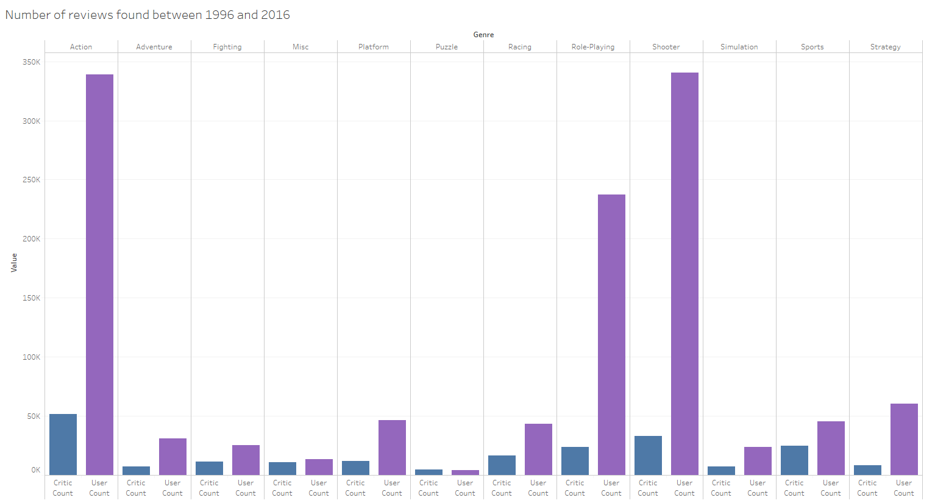

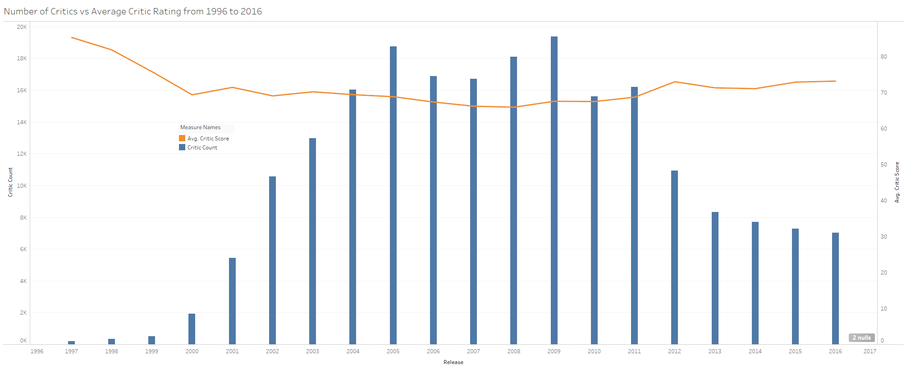

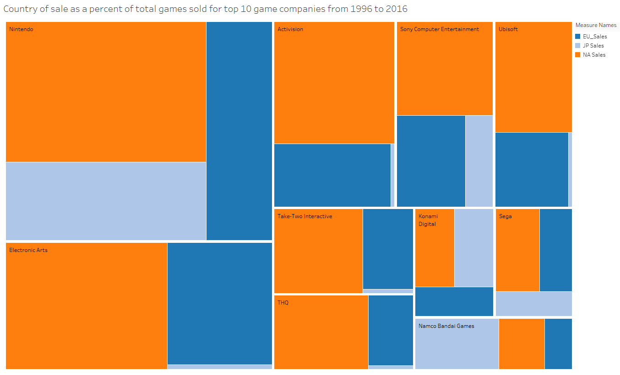

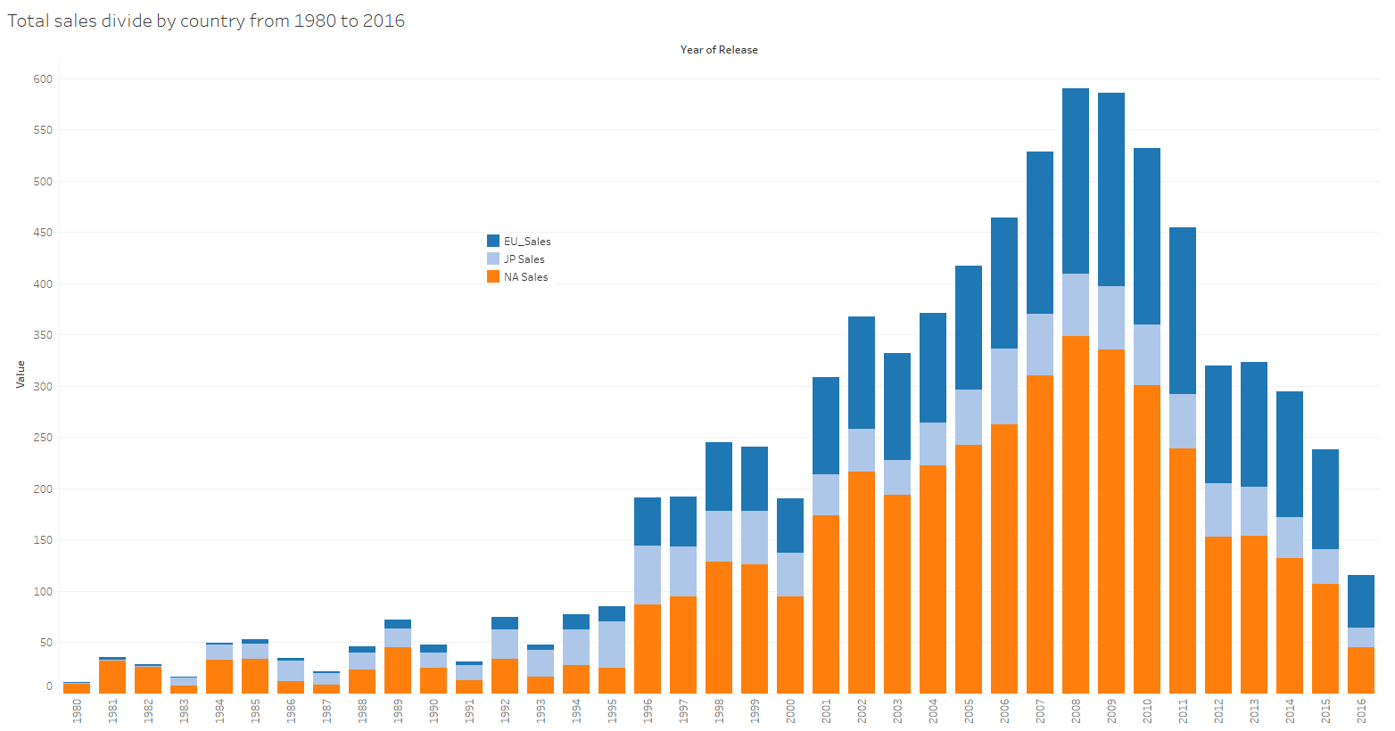

While these charts seem small, they are actually pretty high resolution, so you can zoom in pretty well to see the details.

(credit to Rush Kirubi for video game data, found [here](https://www.kaggle.com/rush4ratio/video-game-sales-with-ratings))

Review of Tableau

1. What do you like about Tableau  
     
   Within 5 minutes of downloading Tableau, and with no prior knowledge of the GUI or what it is capable of, I was about to create a chart that took me 2 hours to do in Google Charts. I don’t have a strong grasp of JavaScript yet, so admittedly that made my time with Charts more difficult. However, I think this is a very strong representation of one of Tableau’s strengths- being that it’s so easy to learn and easy to use for simple representations. As I created more and more charts and graphs I realized why this program is an industry leader, it is very intuitive and from what I’ve seen, also has a very friendly and helpful forum support staff.
2. Which areas of Tableau do you think needs improvement?  
     
   Tableau has a great many algorithms attempting to help out when you change from one representation to another in order to attempt to visualize your data. I thought in the first 20 minutes of using this program that this was a very helpful feature. In the following hours it had become a data filter blackhole. If you are attempting to create a specific chart and must MOMENTARILY delete one specific measure or dimension to bring in a new one, the algorithm is triggered, and it tries to smash all your hard work into a random chart that fits your current specs. This feature has forced me to carefully re-configure specific data points repeatedly all night. Other than that, I felt very boxed in by the smaller number of visualizations offered (smaller than the number of visualizations that I know of and smaller than Google Charts offers), and even those that were offered did not seem to allow all the features I could imagine for them.
3. Which areas is Tableau good for? Which areas are not suitable for Tableau?  
     
   Tableau excels at creating many of the basic charts and graphs quickly and easily. This creates a far reaching appeal for simple data visualization that doesn’t require a STEM degree to visualize. The ability to import a very wide array of database types would also help increase its appeal to companies. However, Tableau was not effective for data creation or more complex labeling and formatting.
4. Google Charts VS Tableau

For the purposes of this project and coming into this class with such a narrow understanding of JavaScript, I found Tableau to be incredibly refreshing as a user. As far as creation of this product goes, I think it would be possible to emulate the basic functionality that Tableau offers using Google Charts. I would think that making a GUI with elements representing different columns and moving those columns to create different visualizations would be difficult. For me personally, the hardest part would be the very large hump of learning JavaScript to create a program with that much functionality. Overall, I think the hardest part would be creating the same kind of ease of use that Tableau offers to its users.